SMARTER SPACE MANAGEMENT SYSTEM

System Requirements Specification Document v 1.0

Nilay Das

Table of Contents:

Introduction 3
Scope: 3
Assumptions 3
Management Summary 3
System Objectives / Overview 4
Figure 1 System Context Diagram 5
Refrences 6
Initial requirement document 6
Common requirements: 6
Error & Exception Handling Requirements 6
Auditing/Logging Requirements 6
Functional Requirement 1 – Developing SSMS 7
Brief Description 7
Interface Details 7
Table of requirement 7
Goods that comes in: 7
JS validation: 9
Goods that Goes out: 9
Requirement Details: 9
Functional Requirement 2 – Email Module 10
Brief Description 10
Table of requirement 11
Sample Email template: 11
Database Schema: 12
SQL Script for table creation: 12
Test Cases: 13
Unit Test Cases – SSMS 13
NFR – Test cases 13
Adhoc Reporting 13
Disclaimer 14
Products to be used: 14
Resource & References: 16

Introduction

Scope:

This document describes the scope of the requirements for the Smart Space Management System (SSMS) for ABC Corp. The document details all the high level requirements with intent to validate ABC’s requirements. This document should be used by the Architect and the developers to design the Solution Architecture for the project.
In addition to this, the document also describes the broad scope of the project
The scope of this project involves developing the SSMS module which maintains the records for the goods that comes in and its space for its customers and an email module which sends out notification to its customer about the availability of their allotted spaces.
The project is to be deployed in the development environment of ABC corp.

Assumptions

The following are the assumptions for this document
· It is assumed that the customers will provide correct mail address for which the notifications are need to be sent and will take appropriate actions on it.

Management Summary

The client ABC is Carrying & Forwarding(C&F) agent, where the manufactured/shipped goods of various MNC’s are parked before it leaves for the wholesale market. Due to the increase of customers for C&F activities and lack of his godown space, the client wants to innovate an application which smartly manages his godown space without loosing his business.
The client now involves manual process for keeping records of the goods/shipment that comes in/goes out of the godown, and accordingly updates his client about the availability of the space for the new shipment to be parked there. This process is manual/time consuming and has went wrong sometimes causing loss of business & trust. The client needs an application which can talk directly to the respective customers to ship their goods for the C&F activities. Its more are like the allotted Godown space itself talking to the allotted company about its availability and capacity so that the company can send their goods/shipment based on the notification and there wont be any loss of business or the space remaining vacant.

The proposed application SSMS, should be able to manage the records of the companies, about their shipment list, and how the C&F activities happened on it. Once a shipment leave the C&F godown, the SSMS should automatically send notification/Email to the corresponding company about the details of the shipment that went out and how much space remaining so that it can be filled in with new shipment from the company. SSMS should also be able to generate reports about handling of shipments from various companies at a given point of time.

System Objectives / Overview

Customers

SSMS
Goods Comes in

Goods Goes out

Email Module

Figure 1 System Context Diagram

The diagram above explains the main conceptual elements in the solution and its
relationships with the architecture. The SSMS component Maintains the space allocation and smart way of exploiting the available space. It gets the information about that goods that comes in to the godown from a particular customer and accordingly adjust their remaining available space by calculating the flow of the good. When a goods goes out of the godown it invokes the email module which sends out an email to the particular owner of that space which the goods occupied about the details of the goods that goes out and updated space availability of that particular customer.

SSMS | Smart Space management system which is going to be built. It can handle the space management by calculating the allotted space for a customer with that of goods that comes in and goes out. It also invokes email module for sending notification with required datas
Email Module | The email module is responsible for sending out email to the particular customer after being invoked by SSMS with necessary data.
Customers | Already existing customers who has been allotted space by ABC for carrying out C& F activity for their goods.

Refrences:

Initial requirement document –

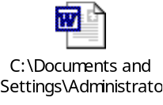

Common requirements:

Error & Exception Handling Requirements
Whenever error happens at SSMS end, it should be properly handled and raised as an exception for manual intervention thru proper logging. In case of failure to send email also the above send process has to be followed

Auditing/Logging Requirements
Proper logging & Auditing has to be done for both goods that comes in and goes out. The logs are also needs to be maintained by orderting Viz.. info, debug, error, exception.

Functional Requirement 1 – Developing SSMS

Brief Description
The SSMS component Maintains the space allocation and smart way of exploiting the available space. It gets the information about that goods that comes in to the godown from a particular customer and accordingly adjust their remaining available space by calculating the flow of the good. When the goods goes out, it has to invoke the email module to send out notification.

Interface Details
The following schematic explains the sequence in SSMS.

SSMS
Goods Comes in

Goods Goes out

Email Module
DB

Table of requirement

Goods that comes in:

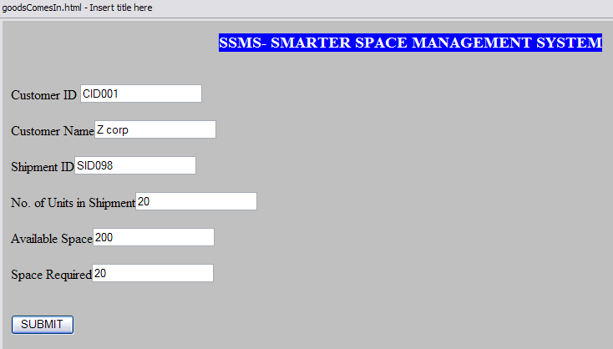

Requirement Details:
SI No | Field Name | Field value
1 | Customer ID | TextBox - The customer ID of the incoming shipment customer
2 | Customer Name | Autopopulating TextBox- Based on the customer id entered, this textbox has to be populated with the respective customer name and its non editable
3 | Shipment ID | TextBox - The shipment ID that has been sent by the customer in the shipment.
4 | No. of units of shipment | TextBox – The total number of units of that particular shipment as mentioned by the customer.
5 | Available space | AutoPopulating Textbox – Based on the Customer ID, it has to fetch the available space for that particular customer and its non editable
6 | Space required | Autopopulating Textbox – Based on the no. of units present in the shipment it has to be auto calculculated and populated and its non editable

JS validation:
JavaScript validation has to be done for the space available and the required space. If the required space is more than the available space then it has to alert the user that required space is more than available space and also disable the submit button.

Goods that Goes out:

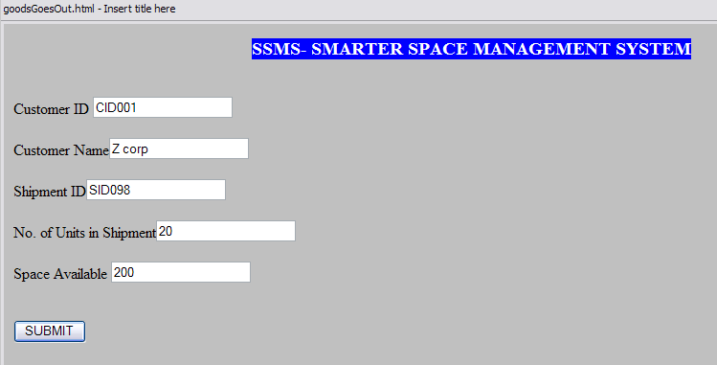

Requirement Details:
SI No | Field Name | Field value
1 | Customer ID | TextBox - The customer ID of the outgoing shipment customer
2 | Customer Name | Autopopulating TextBox- Based on the customer id entered, this textbox has to be populated with the respective customer name and its non editable
3 | Shipment ID | TextBox - The shipment ID that has been sent by the customer in the shipment initially when that shipment came in.
4 | No. of units of shipment | TextBox – The total number of units of that particular shipment as mentioned by the customer.
5 | Available space | AutoPopulating Textbox – Based on the Customer ID, it has to fetch the available space for that particular customer and add it with the number of units of shipment that goes out and populate the textbox and its non editable
6 | SUBMIT | Button - The submit action should corresponding update the DB and also invoke the Email module with the above datas

Functional Requirement 2 – Email Module

Brief Description
Once the Shipment details that goes out is submitted, it has to invoke the email module with the required data for the email module to send out email notification for the respective customer.

Customers

SSMS
Goods Goes out

Email Module
DB

Table of requirement
Flow | For each shipment that goes out of ABC godown, the SSMS invokes the email module with Customer ID, shipment ID, Amount of available space for the customer. The email module fetches the email id of the customer from the DB by using the customer ID and sends out an email to that customer about the details of the available free space.
Exception Handling | In case of failure to send email in the email module, it should be properly handled and proper logging has to be done for manual intervention.

Sample Email template:

Dear <Customer Name>,

Your last shipment that went out is <Shipment ID> and your available free space as on < mm/dd/yyyy T HH:MM> is <Available Space>.

We appreciate your business.

Thanks,
ABC Corp.

Database Schema:

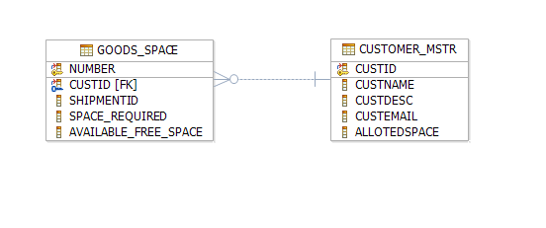

SQL Script for table creation:

This DB scrips were prepared against the derby DB for the above topology.

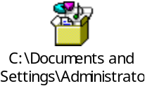

Test Cases:

Unit Test Cases – SSMS

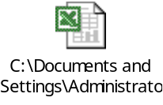

NFR – Test cases

Adhoc Reporting

As a last minute requirement, ABC wants a reporting module for the current space availability in respective of its Customers. The screen requirement is as under.

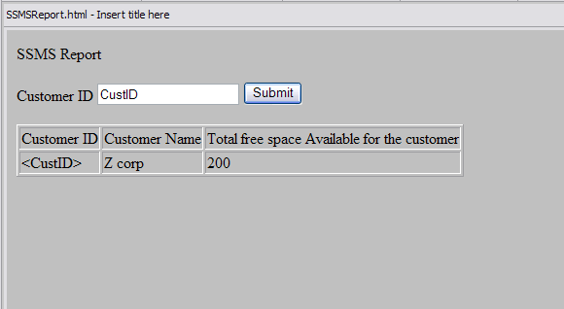

Disclaimer

Most of the DB requirements are captured in the specification. But while developing the solution if the developer has a valid point to add more fields then it can be accommodated after consultation since the DB schema is not freezed as yet.

Products to be used:
Scenario | Product | Description
Developing Use case & UML related activites | IBM Rational Software Modeler, (RSM) | All the UML related specs needs to be developed using RSM only.
Development | IBM Rational Application Developer(RAD) OR WebSphere Integration Developer (WID) | The development of Java/J2EE artifacts should be on RAD or WID only
Database | IBM DB2 V 8.1 or higher | For all the DB requirements, the team should use IBM DB2 only
Team repository | IBM Rational ClearCase | The project team should share there artifacts between them using Rational ClearCase only.
Deployment – Java/J2EE solutions | IBM WebSphere Application Server ND V 6.1 (WAS) | The team should deploy their solutions for testing/production on WAS ND V6.1 only. They should be able to configure the server resources that are required for their solution.

Trademarks

- DB2, IBM, and WebSphere are trademarks or registered trademarks of IBM Corporation in the United States, other countries, or both.
- Windows and Windows NT are registered trademarks of Microsoft Corporation in the United States, other countries, or both.
- Java and all Java-based trademarks and logos are trademarks or registered trademarks of Sun Microsystems, Inc. in the United States, other countries, or both.
- Other company, product, and service names may be trademarks or service marks of others.

IBM copyright and trademark information: http://www.ibm.com/legal/copytrade.phtml
-----------------------------------------------------
Note: Regarding trademarks:

Trademarks Owner
---------- -----
UNIX The Open Group
Intel, Intel Inside logo, MMX, Pentium Intel
Java and Java-related terms Sun (Use ™ , not ® for Java)
Microsoft, Windows, Windows NT, Windows Logo Microsoft
Linux Linus Torvalds

Resource & References:
- WebSphere Application Server on DeveloperWorks- http://www.ibm.com/developerworks/websphere/zones/was/
- Rational Application Developer for WebSphere Software- http://www.ibm.com/developerworks/rational/products/rad/
- Rational Modeler- http://www.ibm.com/developerworks/rational/products/modeler/
- Rational ClearCase- http://www.ibm.com/developerworks/rational/products/clearcase/
- WebSphere Integration Developer- http://www.ibm.com/developerworks/websphere/zones/businessintegration/wps/wps.html
- IBM DB2- http://www.ibm.com/developerworks/data/products/db2/index.html?S_TACT=105AGX11&S_CMP=FP
- IBM RedBooks- http://www.redbooks.ibm.com/

